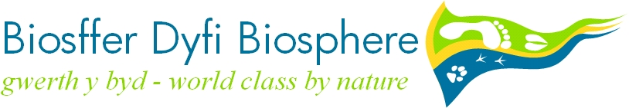

Learning in the Dyfi Valley’s UNESCO Biosphere Reserve

Yellowstone National Park, the Hawaiian Islands, Uluru (Ayer’s Rock), Mount Olympus, the Dyfi Valley…

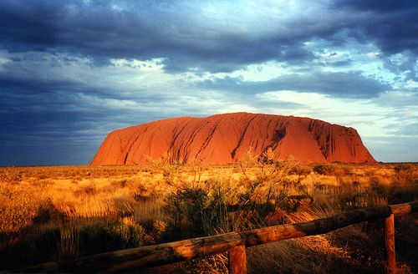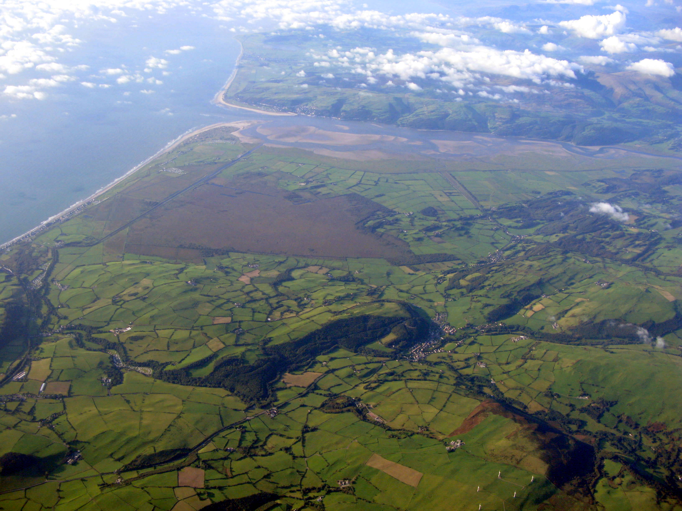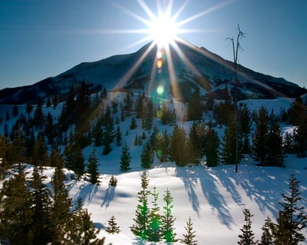

…Just like these iconic places, the Dyfi Valley is a UNESCO Biosphere Reserve, one of 580 in the world, and the only one that exists in Wales.

This status recognises the Dyfi Valley and its surrounding area’s unique and exceptional landscapes and wildlife areas, its rich cultural heritage, its community’s willingness to embrace the benefits the area has to offer, and the work carried out to sustain it into the future.

Biosphere Reserves are valued worldwide as special places for people and nature, with core values of conservation, sustainable development and learning.

The Dyfi Biosphere Partnership, through the work of the Dyfi Biosphere Education group (DBEG), wants to help educators and learners get the maximum benefit from the special learning opportunities that the UNESCO Biosphere Reserve accolade offers. This vision and its intended outcomes are outlined here.

Learning for today’s world

We recognise that learning is a lifelong process that is both formal and informal. It enables children, young people and adults to become confident individuals, and engaged and responsible citizens. With the increasingly pressing social, developmental and environmental challenges that we face today, it is important for people to understand how their environment has changed historically, how it is changing now, and what changes are likely in the future. This will equip them with the knowledge and skills to consider alternative futures - futures that will sustain the environment both locally and globally.

This vision works in synergy with aspirations countrywide. Wales is a progressive nation in terms of sustainable development, reflected in its Government’s ‘One Wales: One Planet’ vision and scheme of work, as well as within its education system with ‘Cwricwlwm Cymreig’ and ESDGC framework (Education for Sustainable Development and Global Citizenship).

The Dyfi Biosphere Reserve provides exciting and engaging opportunities learning activities that encourage people to see the importance of learning to their lives now, and in the future. By bringing people, place and culture together, the Biosphere Reserve supports not just geography and science, but all areas of learning from the arts to history.
Learn about, Learn In, Learn for…

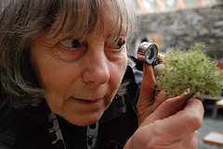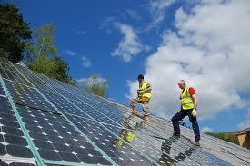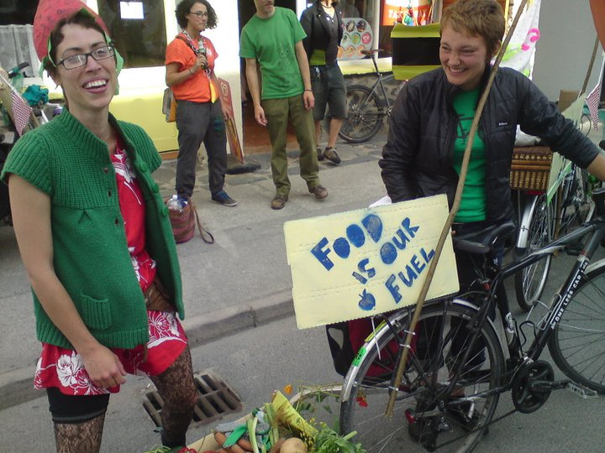

Learning ABOUT the Dyfi Biosphere Reserve will enable learners to…
- Understand what Biosphere Reserves are, and why they are important
- Appreciate why there is a Biosphere Reserve in the Dyfi Valley and its surrounding area
- Understand how the Biosphere relates to local and global challenges
- Understand the concept of change and how people can play a part in shaping the Biosphere to provide a sustainable, high quality environment into the future, locally and globally

Learning IN the Dyfi Biosphere Reserve will enable learners to…
- Observe real life examples of human and natural physical processes of change, and how they are interrelated
- Undertake meaningful enquiries that explore the concept of sustainability
- Embrace the inspiration of the natural environment and human achievements of the Biosphere

Learning FOR the Dyfi Biosphere Reserve will enable learners to…
- Observe and engage with those currently working to sustain the Biosphere, and their visions for the future
- Identify the values and behaviours that will contribute to a sustainable future
- Investigate how they can play part in contributing to a sustainable future, as creative and innovative members of their local and global community
- Develop skills that they can use to help shape that future

Achieving these outcomes

We will promote learning experiences about, in, and for the Dyfi Biosphere Reserve that:
- Accommodate a range of different learning styles, both formal and informal
- Offer schools, colleges, communities and other organisations opportunities for collaboration
- Draw together different aspects of learning or subject disciplines

Facilitating the process: The Dyfi Biosphere Education Group (DBEG)

The DBEG is a growing and diverse network of both formal and informal professional education providers in the Dyfi Biosphere. The group exists to coordinate the delivery of effective education provision within a Biosphere context. As a thematic group of the Dyfi Biosphere Partnership network, it can identify and commission new education projects, provide signposting to potential partners, and give access to Biosphere related learning resources. It aims to evaluate the impact of its work through monitoring and observing changes in knowledge, understanding, skills, values and behaviour amongst those involved

We are an open network that welcomes new members. For more info contact education@dyfibiosphere.org.uk

